We keep records about you and your health so we can look after you. This includes:
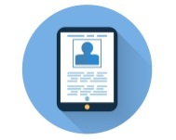
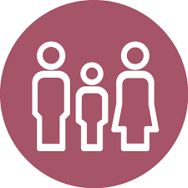
Your name, where you live and how old you are
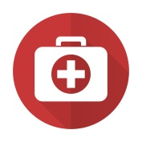
Who you live with and who looks after you

What care we have given you
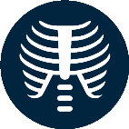
Any photographs we take of you
Results and scans of your body like X-Rays
We keep this information on:


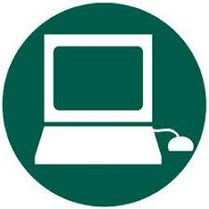
Computers Paper medical records



We always keep your information private

People in the practice who look after you can use your information to look after you.
Sometimes we might need to share your records with other people who look after you, such as the hospital or another doctor or nurse.

People who use your information cannot tell anyone about what you say to them, unless they are worried about your safety, or the safety of someone else.

Sometimes we need to use your information to help other people, to teach them or learn new things. We will remove your name, age and where you live so no one will know it’s about you.

If you want to look at your records or if you have some questions about them, or don’t think they are correct, please ask a member of staff and we can help.

Ask your doctor or nurse any questions you want. You can also speak to the Data Protection Officer whose job it is to help us keep your information safe and private.

